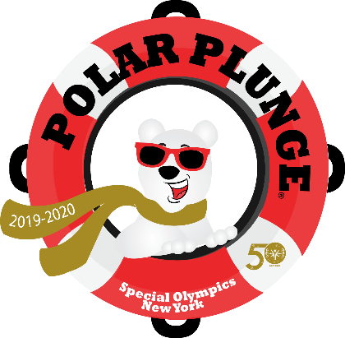

**2020 Polar Plunge Updates**

Instead of large groups congregating and plunging at once, we have restructured the event so that each team and participant will have a personalized Polar Plunge experience in a controlled and safe environment. Polar Plunge waves will be assigned and be compliant with the CDC event guidelines and NYS Governors orders. All spectators and volunteers will be required to wear masks. Plungers will be asked to wear masks up until plunge time.

All Teams and Participants will be plunging in groups of 30-40 as we can only permit 50 people at a time in one area. All plunge waves will be assigned and the first 3 teams to hit their fundraising minimum will be able to choose their plunge time. Because there will be limited time slots, all Plungers must raise at least the minimum of $150 to Plunge and all Teams must raise at least $1,000 for every 10 people on their team.

**Virtual Plunge!**

If you are unable or do not feel comfortable plunging in person, we are having a Statewide Virtual Plunge to be broadcasted on 12/9/20. Register as a Virtual Plunger or Team, raise at least the minimum, and send us your version of the Plunge which you can record at the most convenient time for you.